**Seaborn: Statistical Data Visualization**

**Seaborn** is a Python data visualization library based on **[matplotlib](https://matplotlib.org/)**.

**Seaborn** is a library for making statistical graphics in Python. It is built on top of **[matplotlib](https://matplotlib.org/)** and closely integrated with [**pandas**](https://pandas.pydata.org/)data structures.

**It provides a high-level interface for drawing attractive and informative statistical graphics.**

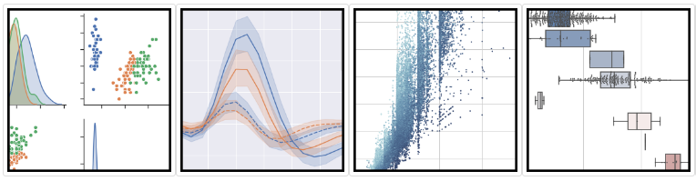

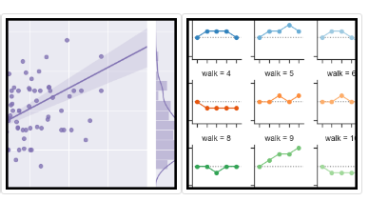

**Here is some of the functionality that seaborn offers:**

* A dataset-oriented API for examining [**relationships**](https://seaborn.pydata.org/examples/scatter_bubbles.html#scatter-bubbles) between [**multiple variables**](https://seaborn.pydata.org/examples/faceted_lineplot.html#faceted-lineplot)
* Specialized support for using categorical variables to show [**observations**](https://seaborn.pydata.org/examples/jitter_stripplot.html#jitter-stripplot)or [**aggregate statistics**](https://seaborn.pydata.org/examples/pointplot_anova.html#pointplot-anova)
* Options for visualizing **[univariate](https://seaborn.pydata.org/examples/distplot_options.html" \l "distplot-options)** or**[bivariate](https://seaborn.pydata.org/examples/joint_kde.html" \l "joint-kde)** distributions and for [**comparing**](https://seaborn.pydata.org/examples/horizontal_boxplot.html#horizontal-boxplot)them between subsets of data
* Automatic estimation and plotting of [**linear regression**](https://seaborn.pydata.org/examples/anscombes_quartet.html#anscombes-quartet) models for different kinds [dependent](https://seaborn.pydata.org/examples/logistic_regression.html#logistic-regression) variables
* Convenient views onto the overall [**structure**](https://seaborn.pydata.org/examples/scatterplot_matrix.html#scatterplot-matrix) of complex datasets
* High-level abstractions for structuring [**multi-plot grids**](https://seaborn.pydata.org/examples/faceted_histogram.html#faceted-histogram) that let you easily build [**complex**](https://seaborn.pydata.org/examples/pair_grid_with_kde.html#pair-grid-with-kde) visualizations
* Concise control over matplotlib figure styling with several [**built-in themes**](https://seaborn.pydata.org/tutorial/aesthetics.html#aesthetics-tutorial)
* Tools for choosing **[color palettes](https://seaborn.pydata.org/tutorial/color_palettes.html" \l "palette-tutorial)** that faithfully reveal patterns in your data

Seaborn aims to make visualization a central part of exploring and understanding data. Its dataset-oriented plotting functions operate on dataframes and arrays containing whole datasets and internally perform the necessary semantic mapping and statistical aggregation to produce informative plots.